**RESUME**

**MOHAMMAD FAROOK**

**Address: MORADABAD**

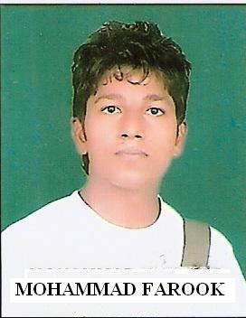

**Mobile: 09457632608, 09058097909 E-mail: mohammad.farook00005@gmail.com**

**OBJECTIVE: -** To enhance my knowledge continue. To upgrade my skill, Explore my knowledge. Seeking for a challenging career in a reputed organization.

**EDUCATIONAL QUALIFICATIONS**:-

|  |  |  |  |
| --- | --- | --- | --- |
| **Qualification** | **Board/ University** | **Year of passing** | **Percentage of marks** |
| B. Tech (Electronics & Communication) | IFTM University | 2015 | 64.55 |
| Intermediate | U.P Board | 2009 | 57.6 |
| High School | U.P Board | 2007 | 54.33 |

**WORKING EXPERIENCE:-**

* Currently working as site engineer in “WESTIN ELECTROMECH” Pvt. Ltd. Office No:- 41,47 Palika Market, Ghaziabad, UP, India Since 10 May 2015.

**TRAINING, SHORT TERM COURSES & WORKSHOPS**:-

* Name of Institution:- “BHEL” Haridwar
* Name of the Program:- Summer Training in 3rd Year
* Course Content:- Introduction to “CNC MACHINE”
* Duration:- 6 week
* Name of Institution:- “SCORPIX INDIA” Pvt. Ltd. Ghaziabad
* Name of the Program:- Summer Training in 2nd Year
* Course Content:- Introduction to “TELECOM” & “AMBEDED”
* Duration:- 4 week

**ACADEMIC PROJECTS AND PRESENTATIONS:-**

* Major project on “ MICROCONTROLLER” Based “AMBEDED” System Used in “STREET LIGHT”
* Presentation on “TV JAMMER REMOTE”

**KEY SKILLS:-**

* Knowledge of computer
* Good communication skill

**STRENGTHS:-**

* Creative
* Quick and continue learner
* Love to learn new things
* Self-motivated

**FAVOURITE SUBJETS:-**

* Basic Electronics, Electronics Engineering

**PERSONAL INFORMATION:-**

* DOB: 16-03-1991
* Father’s Name: Mr. Babu Shah
* Gender: Male
* Nationality: Indian
* Language: Hindi & English
* Permanent Address: Vill- Satuiya Khurd, Teh.- Nawabganj, Dist.- Bareilly (U.P.)

**DECLARATION:-**

I do hereby declare that the particulars of information and facts stated herein above are true, correct and complete to the best of my knowledge and belief.

**PLACE: JAMSHEDPUR MOHAMMAD FAROOK**

**DATE:**